Travel And Tourism Website

Software Requirements Specification

10-04-2024

Pranjal Singh

Prepared for
Continuous Assessment 3
Spring 2024

Revision History

Date | Description | Author | Comments
7-04-2024 | 1.0 | Pranjal Singh | Initial code of the website
9-04-2024 | 1.1 | Pranjal Singh | Added styling to the website

Table of Contents

Revision History ii
CLIENT Approval Error! Bookmark not defined.
1. Introduction 1
1.1 Purpose 1
1.2 Scope 2
1.3 Definitions, Acronyms, and Abbreviations 3
1.4 References 4
1.5 Overview 4
2. General Description 5
2.1 Product Perspective 5
2.2 Product Functions 5
2.3 User Characteristics 7
2.4 General Constraints 7
2.5 Assumptions and Dependencies 7
3. Specific Requirements 8
3.1 External Interface Requirements 8
3.1.1 User Interfaces 8
3.1.2 Hardware Interfaces 8
3.1.3 Software Interfaces 9
3.1.4 Communications Interfaces 9
3.2 Functional Requirements 10
3.2.1 Home Page 10
3.2.2 About Page 10
3.5 Non-Functional Requirements 10
3.5.1 Performance 10
3.5.2 Reliability 10
3.5.3 Availability 10
3.5.4 Security 11
3.5.5 Maintainability 11
3.5.6 Portability 11
3.7 Design Constraints 11
3.9 Other Requirements 12
4. Analysis Models 12
4.1 Data Flow Diagrams (DFD) 12
A. Appendices 13
A.1 Appendix 1 13
A.2 Appendix 2 14

Travel And Tourism Website

Abstract—the development of the “Unforgettable Journey” Travel and Tourism Website. It serves as a comprehensive guide for software engineers and developers, detailing the functional and non-functional requirements, scope, audience, document structure, and conventions. The website aims to provide an intuitive and user-friendly platform for customers to access gym website services and information conveniently. This document ensures clear communication and alignment with project objectives throughout the development process.

Introduction
With the most recent developments and changes in the business environment, data and information must be effectively gathered, managed and stored in order to keep pace and compete in the event industry. Thus, an easier and cost-efficient manner of handling information is necessary.
The website's primary purpose is to provide users with access to information about various travel destinations and services offered by the company. It serves as a hub for planning travel experiences, including exploring travel packages, destinations, and contacting the company for inquiries and bookings.
Unforgettable Journeys Travel and Tourism is dedicated to delivering personalized, high-quality travel experiences tailored to each client's unique preferences. Through this website, users can seamlessly navigate different sections such as the Home page, About page, Service page, Contact page, and Sign-Up page to engage with the company's offerings and discover the wonders of travel.
This SRS document serves as a guide for understanding the functional, non-functional, and interface requirements of the website to ensure that it meets the expectations of users and the objectives of the company.

1.1 Purpose

The purpose of this Software Requirements Specification (SRS) is to provide a detailed description of the functional and non-functional requirements for the Unforgettable Journeys Travel and Tourism website. This document serves as a reference for the development team, stakeholders, and any other interested parties to understand the project's objectives and requirements.

The SRS outlines how the website should function, the features it should include, and the user experience it should deliver. By clearly defining the requirements, the SRS helps guide the development process to ensure that the final product meets the expectations and needs of both the company and its users.
The purpose of the Unforgettable Journeys Travel and Tourism website is to serve as a comprehensive platform for travel planning and booking. The website aims to:

- Provide Information: Offer users detailed information about travel destinations, packages, and services offered by the company.
- Facilitate Travel Planning: Assist users in planning their trips by providing various options for destinations, accommodations, and activities.
- Streamline Booking: Enable users to book travel packages and services directly through the website, providing a convenient and efficient booking process.
Audience
This SRS document is intended for the following audience:
Software Engineers and Developers: To understand the technical specifications and implementation details required to build the website.
Project Managers: To ensure that the project aligns with the defined requirements and objectives.
Quality Assurance Teams: To develop test cases and ensure the website's functionality meets the specified requirements.
Stakeholders and Clients: To gain insight into the project's scope and functionalities

Scope
The Software Requirements Specification (SRS) for the Unforgettable Journeys Travel and Tourism website outlines the functional and non-functional requirements of the web-based application. This application is designed to serve as a comprehensive platform for planning, booking, and managing travel experiences for customers.

The scope of this SRS includes:

Home Page: Providing an overview of the company's offerings and featured destinations or services.
About Page: Describing the company's history, mission, and values.
Service Page: Detailing the various travel services and packages available, including tours, accommodations, and activities.
Contact Page: Allowing users to get in touch with the company through a contact form or other provided contact information.
Sign-Up Page: Enabling users to create an account for personalized experiences and to manage their bookings.
Navigation and Routing: Defining the routes and navigation structure of the website, enabling seamless user interaction.
User Experience: Ensuring the website is user-friendly, intuitive, and provides a consistent experience across all pages.
Performance: Specifying the performance requirements of the website, including speed and reliability.
Security: Outlining security measures to protect user data and prevent unauthorized access.
Maintainability: Defining requirements to facilitate easy maintenance and updates to the website.
Accessibility: Ensuring the website is accessible to all users, including those with disabilities.
The SRS focuses on these aspects to provide clear guidance for the development team, ensuring the website meets the expectations of the company and its users, and aligns with industry standards and best practices for web applications.

Definitions, Acronyms, and Abbreviations

Home: The main landing page of the website, where users can find general information about the company and its services.

About: A page that provides information about the company, including its history, mission, values, and team.

Service: A page that offers details about the various travel services and packages provided by the company, including tours, excursions, and accommodations.

Contact: A page with a form and contact details where users can reach out to the company for inquiries, bookings, or feedback.

Sign-Up: A page that allows users to create an account for personalized experiences, including the ability to manage bookings and access exclusive content.

Navigation: The system of menus and links that allow users to move between different pages and sections of the website.

Route: A specific path defined in the website's code that corresponds to a particular page or component, allowing users to navigate directly to it.

User Interface (UI): The visual elements of the website that users interact with, including pages, buttons, forms, and menus.

User Experience (UX): The overall experience a user has while navigating and interacting with the website, including ease of use, satisfaction, and accessibility.

Responsive Design: A design approach that ensures the website functions and looks good on different devices, such as desktops, tablets, and smartphones.

Search Engine Optimization (SEO): The practice of optimizing the website to improve its visibility in search engine results.

Cascading Style Sheets (CSS): A style sheet language used for describing the look and formatting of a document written in HTML.

Hypertext Markup Language (HTML): A standard markup language used to create and structure content on the web.

JavaScript: A programming language commonly used to create interactive effects within web browsers.

React: A JavaScript library for building user interfaces, particularly single-page applications.

State: In the context of a React application, the data that determines how components render and behave.

Props: In React, properties that are passed from parent components to child components to allow customization.

Functional Component: A type of React component that is defined as a function and returns JSX.

Class Component: A type of React component that is defined as a class and can hold its own state and lifecycle methods.

1.4 References
The Unforgettable Journeys Travel and Tourism website references various standards, frameworks, and best practices to ensure the development of a high-quality web application. The following references provide guidance for the implementation and maintenance of the website:

- React Documentation: The official documentation for the React library used in the website's development. It provides information on component structure, state management, routing, and more.
React Documentation
- React Router Documentation: The official documentation for the react-router-dom package used for routing and navigation in the application.
React Router Documentation
- CSS Documentation: Resources and guides on CSS for styling web applications, including best practices for responsive design and accessibility.
MDN Web Docs - CSS
- HTML Documentation: Resources and guides on HTML for structuring content on web pages.
MDN Web Docs - HTML
- JavaScript Documentation: Resources and guides on JavaScript for adding interactivity and functionality to web applications.
MDN Web Docs - JavaScript

1.5 Overview

This Software Requirements Specification (SRS) document outlines the requirements for the Unforgettable Journeys Travel and Tourism website, serving as a guide for its development. It provides a comprehensive description of the features, functionalities, and constraints of the web application.
The Unforgettable Journeys Travel and Tourism website is a comprehensive online platform designed to provide users with seamless travel planning and booking experiences. The website serves as the digital hub for the travel and tourism company, offering a range of services and information to cater to various types of travelers.
The website is developed using the React framework, enabling efficient state management, component reusability, and responsive design. The react-router-dom package is used for routing and navigation, facilitating seamless movement between different pages and sections of the site.

The application focuses on delivering a user-friendly and engaging experience, ensuring smooth performance and reliable operation across different devices and browsers. Security and accessibility are also prioritized to protect user data and ensure an inclusive experience for all users.

2. General Description
The Unforgettable Journeys Travel and Tourism website is a web-based platform designed to provide users with an easy and efficient way to plan, book, and manage their travel experiences. The application is built using the React framework, which allows for efficient state management and component reusability. The website uses the react-router-dom package to handle routing and navigation, enabling seamless transitions between different pages and sections.

Key features of the website include:

Home Page: The main landing page that provides users with a brief overview of the company's offerings, including featured destinations and services. It serves as the starting point for navigating the site.
About Page: A page that introduces users to the company's history, mission, values, and team members.
Service Page: A detailed page showcasing the various travel packages, tours, and excursions offered by the company, helping users plan their trips.
Contact Page: A page that includes a contact form and company contact details, allowing users to reach out for inquiries or support.
Sign-Up Page: A page where users can create an account to personalize their experience and manage their bookings.
The website is designed to offer a user-friendly and engaging experience, with a focus on performance, usability, and accessibility. It caters to a broad range of travelers, from those seeking adventure to those looking for relaxation and cultural experiences.

2.1 Product Perspective
The Unforgettable Journeys Travel and Tourism website is a web-based application designed to serve as a comprehensive platform for planning, booking, and managing travel experiences for customers. The website acts as the digital storefront for the company, providing users with access to information about travel destinations, packages, and services offered.

The website is a part of the company's overall digital strategy to enhance customer engagement and streamline travel planning. It serves as a self-service platform where users can interact with the company to explore travel options, request bookings, and access additional resources such as blogs and travel tips.

2.2 Product Functions
The Unforgettable Journeys Travel and Tourism website provides users with a range of functions to facilitate travel planning, booking, and management. The main product functions include:

- Home Page:
Provides an overview of the company's offerings, including featured destinations and services.
Acts as the starting point for users to navigate the website.
May include links to popular sections such as tours, packages, and promotions.
- About Page:
Offers information about the company's history, mission, values, and team members.
Helps establish trust and rapport with users by providing insight into the company.
- Service Page:
Describes the various travel services and packages offered by the company, including tours, accommodations, and activities.
Allows users to browse and explore different travel options based on their interests.
- Contact Page:
Provides users with contact information such as phone numbers and email addresses.
Includes a contact form for users to submit inquiries, feedback, or booking requests.
Facilitates direct communication between users and the company.
- Navigation and Routing:
Uses the react-router-dom package to enable smooth navigation between different pages.
Provides an intuitive menu system for users to access various sections of the website.
- User Interaction:
Enables users to interact with the website through forms, buttons, and other interactive elements.
May include features such as reviews, ratings, and user-generated content.
- Responsiveness and Accessibility:
Ensures the website functions seamlessly across different devices, including desktops, tablets, and smartphones.
Adheres to accessibility standards to provide an inclusive experience for all users.
The website's functions work together to offer users a comprehensive and engaging platform for exploring, planning, and booking their travel experiences. The goal is to create a seamless and enjoyable journey for each user, from the initial planning stages to the final booking and beyond..

2.3 User Characteristics
The Unforgettable Journeys Travel and Tourism website caters to a diverse range of users with varying interests, backgrounds, and needs. Understanding the user characteristics is essential for delivering a seamless and personalized experience. The primary user groups are as follows:

- Leisure Travelers:
Individuals or families looking for vacation packages, excursions, and leisure activities.
Interested in exploring different destinations and cultural experiences.
Seek relaxation, adventure, and memorable experiences during their travels.
- Business Travelers:
Professionals who travel for work and may require specific travel arrangements.
Prioritize efficiency and convenience in travel planning and booking.
May seek accommodations close to business districts or conference centers.
- Adventurers:
Travelers seeking exciting and unconventional experiences, such as trekking, hiking, or wildlife tours.
Interested in exploring off-the-beaten-path destinations and engaging in outdoor activities.
- Cultural Enthusiasts:
Individuals interested in immersing themselves in local cultures, traditions, and history.
May seek guided tours, museum visits, or participation in local events and festivals.
- Family Travelers:
Families planning trips that accommodate the needs of different age groups.
Look for family-friendly destinations and activities, as well as suitable accommodations.
- Budget-Conscious Travelers:
Individuals or groups who prioritize affordability and value for money.
Seek travel deals, promotions, and cost-effective options for accommodations and activities.
- Luxury Travelers:
Individuals looking for high-end, premium experiences during their travels.
Seek luxurious accommodations, exclusive tours, and personalized services.
- Digital Natives:
Users familiar with technology and digital platforms, expecting a seamless online experience.
Likely to use the website for planning, booking, and managing their travels.
Regardless of the user group, all users expect the website to be easy to navigate, informative, and responsive. They value clear and concise information about travel options, transparent pricing, and secure booking processes. The website should also accommodate different levels of familiarity with travel and technology, ensuring an inclusive experience for all users.).

2.4 General Constraints

The development and deployment of the Unforgettable Journeys Travel and Tourism website are subject to certain constraints that must be considered to ensure the product functions effectively and meets user expectations
- Browser Compatibility:
  - The website must be compatible with a range of modern web browsers, including Google Chrome, Mozilla Firefox, Safari, and Microsoft Edge.
- Responsive Design:
  - The application must provide a consistent and user-friendly experience across various devices, including desktops, tablets, and smartphones.
- Performance:
  - The website must offer fast load times and smooth interactions for an optimal user experience.
- Security:
  - User data must be protected through encryption and secure storage practices.
- Accessibility:
  - Features such as alt text for images and keyboard navigation should be included.
- Internationalization:
  - Proper handling of dates, currencies, and time zones is essential for a global audience.
- Maintainability:
  - Best practices such as code comments, version control, and automated testing should be followed.
- Legal and Regulatory Compliance:
  - It should also adhere to industry-specific regulations related to travel and tourism.

2.5 Assumptions and Dependencies
- Assumptions:
  - Users have access to modern web browsers and internet connectivity.
  - Users have a basic understanding of how to navigate a website.
  - Users will provide accurate and truthful information when creating accounts or making bookings.
  - Third-party services (e.g., payment gateways, maps, or booking APIs) will be available and functional as expected.
- Dependencies:
  - The application relies on the React framework for building user interfaces and state management.
  - The application uses the react-router-dom package for routing and navigation.
  - External APIs or services may be used for functionalities such as payment processing, geolocation, or booking management.
  - The performance and availability of the website may depend on the hosting infrastructure and server uptime.
  - Compliance with security and data protection standards relies on the proper configuration and maintenance of the application and associated systems.
.

3. Specific Requirements
This section presents the specific requirements for the development of the Website. These requirements serve as the foundation for guiding the project's software design, implementation, and testing. Each requirement is carefully structured to ensure correctness, traceability, clarity, verifiability, prioritization, completeness, consistency, and uniqueness.

3.1 External Interface Requirements

3.1.1 User Interfaces
The Unforgettable Journeys Travel and Tourism website features user interfaces designed to be intuitive, engaging, and consistent across all pages. Key aspects include:
- Clear Navigation
- Responsive Design
- Interactive Elements
- Visual Appeal
- Accessibility

Hardware Interfaces
The Unforgettable Journeys Travel and Tourism website does not require any specific hardware interfaces for its users beyond standard consumer devices. Users can access the website using a variety of common hardware:

Desktops and Laptops: Users can access the website on standard desktop or laptop computers equipped with a modern web browser.
Mobile Devices: The website is designed to be responsive and can be accessed on smartphones and tablets, providing a consistent user experience across different screen sizes.
Input Devices: Users can interact with the website using standard input devices such as a keyboard, mouse, or touch screen.
Network Connectivity: Access to the website requires an internet connection, either through wired (Ethernet) or wireless (Wi-Fi, mobile data) networks.

Software Interfaces
The Unforgettable Journeys Travel and Tourism website interacts with various software systems and services to provide its functionalities and ensure seamless operation. Key aspects of the software interface include:

React: The website is built using the React framework, allowing for efficient state management, reusable components, and a responsive user interface.
react-router-dom: The website uses the react-router-dom package for routing and navigation, enabling smooth transitions between different pages and sections.
External APIs: The application may integrate with external APIs for functionalities such as payment processing, geolocation, booking management, and other third-party services.
Back-End Systems: The website may interface with back-end systems to manage user data, bookings, and business operations. This integration allows for a smooth flow of information and data consistency across the application.
Database: User data, bookings, and other relevant information may be stored in a database. The application interacts with the database to retrieve and update data as needed.
Security: The website ensures secure communication and data handling through the use of industry-standard encryption protocols such as HTTPS.

Functional Requirements
The Unforgettable Journeys Travel and Tourism website includes the following specific functional requirements:

- Home Page:
Provide an overview of featured destinations and services.
Offer navigation links to other sections of the website.
- About Page:
Present information about the company's history, mission, and values.
Service Page:
Describe available travel packages, tours, and accommodations.
Allow users to explore different options based on their interests.
- Contact Page:
Include a contact form for inquiries and support.
Provide contact details such as phone numbers and email addresses.
- Sign-Up Page:
Enable users to create an account by providing their information.
Allow users to manage their bookings and access personalized content.
- Navigation and Routing:
Use react-router-dom for seamless navigation between pages.
Provide intuitive menus for accessing various sections of the website.
- User Interaction:
Facilitate interaction through forms, buttons, and other UI elements.
Allow users to submit inquiries, feedback, and bookings.
These functional requirements ensure the website provides a comprehensive and engaging platform for users to explore and plan their travel experiences.

3.5 Non-Functional Requirements
The Unforgettable Journeys Travel and Tourism website must meet various non-functional requirements to ensure a smooth, secure, and user-friendly experience for all users:
- Usability:
  - The website should have an intuitive and consistent user interface that is easy to navigate.
  - Clear labels, menus, and prompts should guide users through different sections and actions.
  - Accessibility standards such as the Web Content Accessibility Guidelines (WCAG) should be followed.
- Performance:
  - The website should load quickly and respond promptly to user actions.
  - Optimal performance can be achieved through efficient coding practices, caching, and optimization techniques.
- Security:
  - User data and communication should be protected using industry-standard encryption protocols such as HTTPS.
  - Secure authentication mechanisms should be implemented for user accounts.
- Scalability:
  - The website should handle varying levels of traffic and user activity without performance degradation.
  - The infrastructure should support future growth in terms of user base and features.
- Maintainability:
  - The application should be designed in a modular and reusable manner, making it easier to maintain and update.
  - Clean coding practices, documentation, and version control should be followed.
- Reliability:
  - The website should operate consistently and be available with minimal downtime.
  - Measures such as monitoring and error handling should be implemented to ensure reliability.
- Compatibility:
  - The website should be compatible with a range of modern web browsers and devices.
  - It should function well on various operating systems and platforms.
- Internationalization:
  - The website should support multiple languages and cultural variations for a global audience.
  - Proper handling of dates, currencies, and time zones is necessary.
- Legal and Ethical Compliance:
  - The website must comply with applicable laws and regulations, including those related to data privacy and consumer protection.
  - Ethical practices should be followed in terms of content, advertising, and user engagement.

3.7 Design Constraints
The development and design of the Unforgettable Journeys Travel and Tourism website must adhere to certain constraints to ensure the application functions effectively and meets user expectations. These constraints include:
Responsive Design:
  - The website must provide a consistent and user-friendly experience across various devices, including desktops, tablets, and smartphones.
  - Design elements should adapt to different screen sizes and orientations.
Browser Compatibility:
  - The application must be compatible with a range of modern web browsers, including Google Chrome, Mozilla Firefox, Safari, and Microsoft Edge.
  - It should maintain basic functionality on older versions of popular browsers.

3.9 Other Requirements
This section outlines additional requirements for the Unforgettable Journeys Travel and Tourism website that may not fall under functional or non-functional categories but are essential for its success and proper operation:
- Content Management:
  - The website should integrate with a content management system (CMS) to allow easy updates and management of text, images, and other content.
  - Administrators should be able to add, edit, or remove content as needed.
- Search Functionality:
  - A search feature should be provided to allow users to quickly find specific information, destinations, or services on the website.
  - Search functionality should be efficient, accurate, and user-friendly.
- Feedback Mechanism:
  - The website should include a method for users to provide feedback on their experiences, whether through forms, reviews, or ratings.
  - Feedback should be collected, analyzed, and used to improve the website and services.
- Logging and Monitoring:
  - The application should implement logging and monitoring to track user interactions and identify potential issues.
  - Logs can help diagnose problems, track performance, and ensure proper application behavior.
.

4. Analysis Models

4.1 Data Flow Diagrams (DFD)
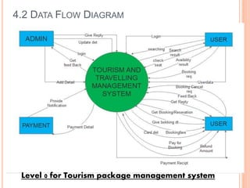

A. Appendices

A.1 Appendix 1
ScreenShot of Code:-
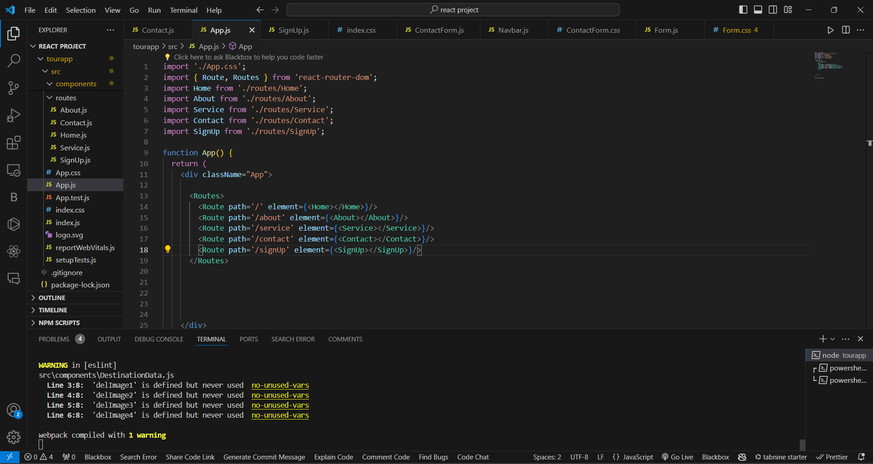
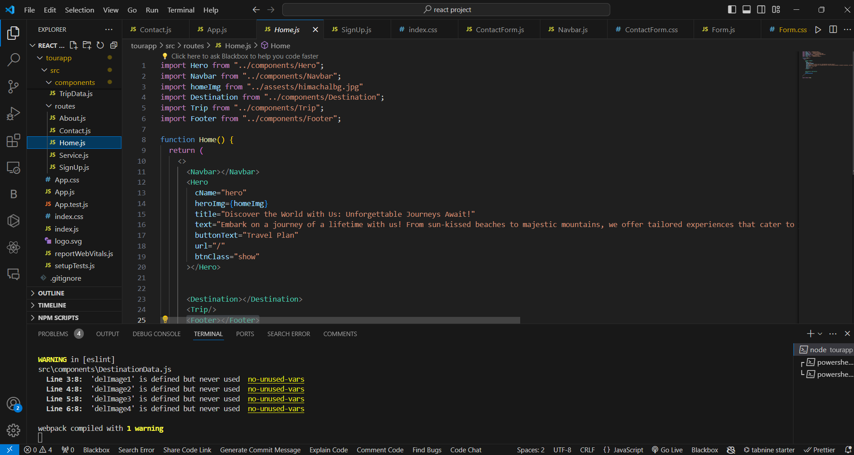

A.2 Appendix 2
ScreenShot of Website:

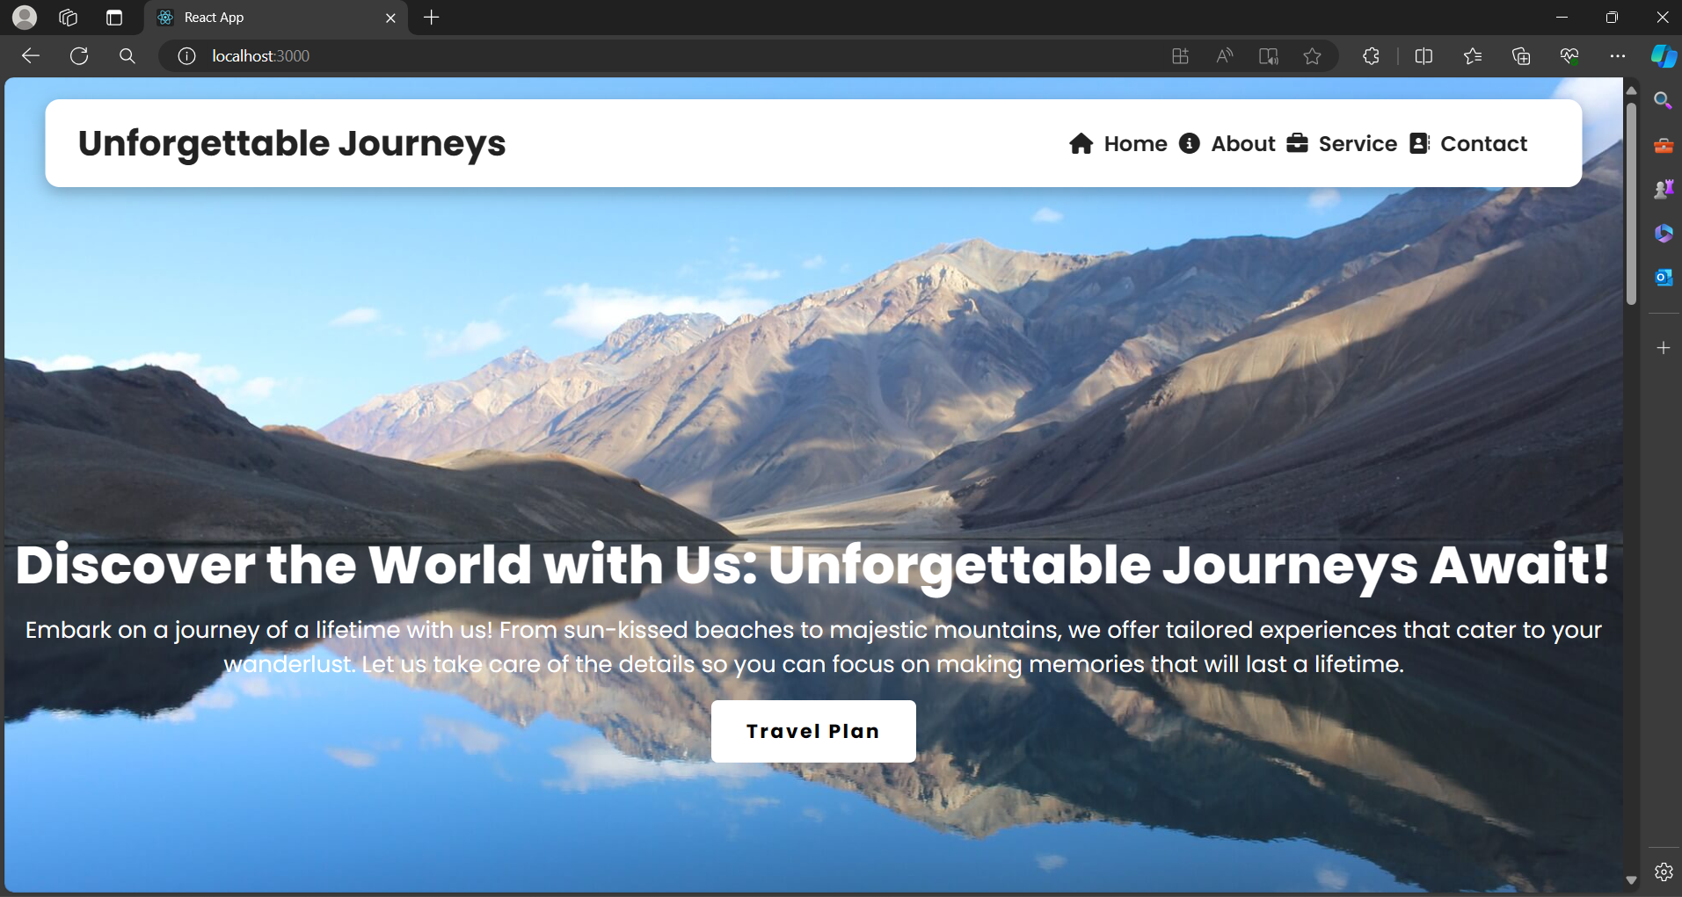

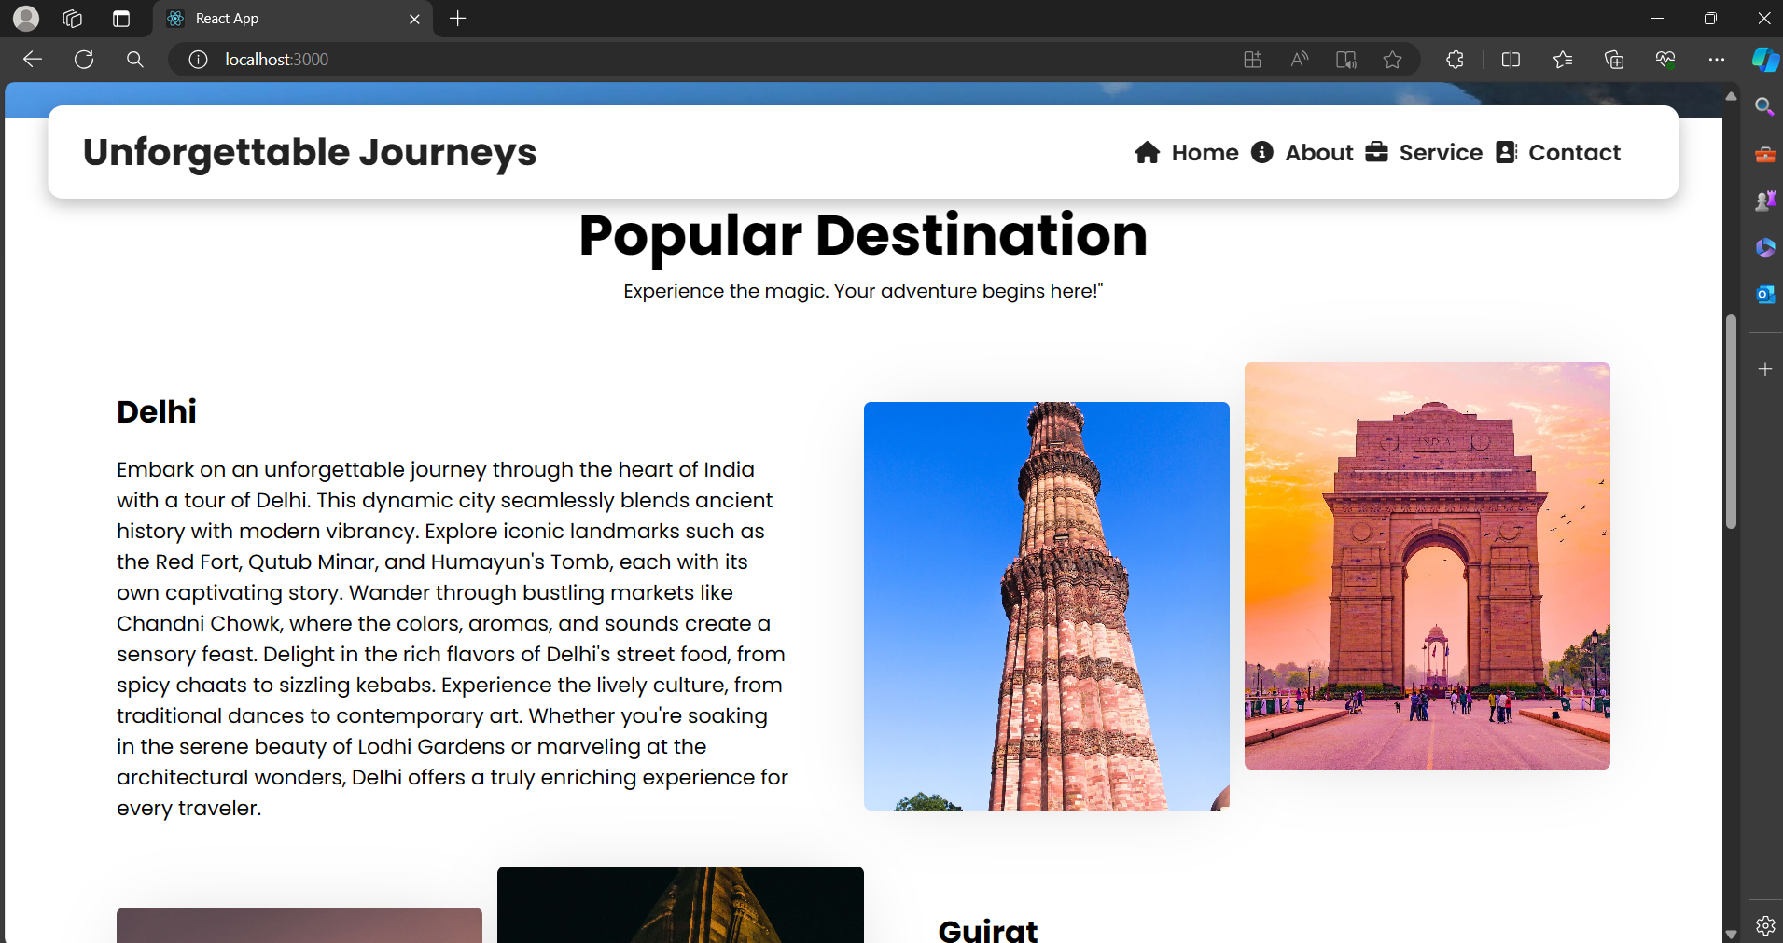

THANK YOU

